Python Packages for Solving ODEs and Techniques for Measuring Computing Time
- Python Packages for Solving Ordinary Differential Equations
Python has several packages that can solve ordinary differential equations (ODEs). One commonly used package is SciPy, which provides the solve_ivp() function in its scipy.integrate module. solve_ivp() supports several numerical methods, including RK45, RK23, DOP853, Radau, BDF, and LSODA.
For example, the following code solves the ODE $\frac{dy}{dt}=-2y$ with the initial condition $y\left(0\right)=1$.
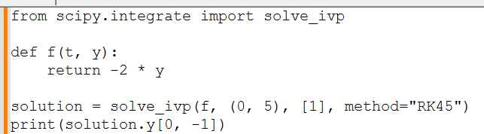
SciPy is useful because it performs the numerical calculations automatically instead of requiring the programmer to manually calculate each Runge-Kutta step.
Other Python packages for solving ODEs include scikits.odes and Assimulo, which provide additional numerical solvers and are useful for more specialized problems.

- Measuring Computing Time in Python
Python provides several ways to measure how long a program takes to execute. One simple method is time.perf_counter(). It provides a high-resolution timer that can be used to measure elapsed time.

For example:
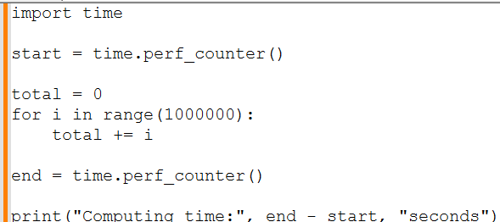

The difference between end and start gives the approximate time required to execute the calculation.

Another option is Python's timeit module. timeit is designed for benchmarking and can run a calculation multiple times to obtain more reliable timing results. cProfile can also be used when the goal is to determine which parts of a program are taking the most time.

Overall, solve_ivp() is a convenient way to solve ODEs in Python, while perf_counter() and timeit provide simple ways to measure the performance of Python programs.
References
Python Software Foundation. (2026). time — Time access and conversions. Python 3.14.8 documentation. https://docs.python.org/3/library/time.html
Python Software Foundation. (2026). timeit — Measure execution time of small code snippets. Python 3.12.14 documentation. https://docs.python.org/3/library/timeit.html
Python Software Foundation. (2026). The Python profilers. Python 3.14.8 documentation. https://docs.python.org/3/library/profile.html
SciPy Developers. (2026). solve_ivp. SciPy documentation. https://docs.scipy.org/doc/scipy/reference/generated/scipy.integrate.solve_ivp.html
Malengier, B., Kišon, P., Tocknell, J., Abert, C., Bruckner, F., & Bisotti, M.-A. (2018). ODES: A high level interface to ODE and DAE solvers. Journal of Open Source Software, 3(22), 165. https://doi.org/10.21105/joss.00165

